Report - Web design – Michael Markey - D24129565

For this project, I have decided to create a CV website. This made the most sense for me as I am currently looking for an internship this summer, so working on content where I present myself and my professional background has been useful and made this evaluation more interesting for me.

I decided to create a site from scratch. Before this course, I had created web content using no-code tools such as WebFlow and Wordpress. These tools allow for ‘non-coders’ to quickly put together a relatively professional website in a short amount of time; the issue, however, is that once there is a requirement to modify or add individualized content, these tools become obtuse and unwieldy. I saw this course as the opportunity to create something for myself that I have full control over and that I fully understand. While we did see grid tools and CSS frameworks in class, I found them to be too rigid for my website.

My approach to building the website was quite simple – I had already sketched out a prototype for the first part of this assignment, so I took this as my starting point and created each HTML page with rudimentary code so that I could quickly ‘mock up’ the final product. I then added CSS in order to bring each page into line with the vision presented in the prototype. Through trial and error, I managed to find a layout that worked for me – a hero section on each page, followed by blocks of information and/or project cards that expanded on the themes and ideas presented on the page/in the hero section.

I then moved on to creating the frame for each page. I did not want to present myself on each page, so I decided on placing my ‘signature’ on the top-left corner of each page. This for me was a relatively subtle way of keeping my name present as the user scrolls through the website. I also used a favicon with a home-made logo of my initials as a placeholder in the browser tab, along with a short description of the website. My menu is classic in form – a home page, a page on what I am doing now (current), a page on my professional experience (background), a page on myself (about me) and a contact page.

I used CSS and JavaScript to create a hamburger menu that appears on smaller devices – this avoids cluttering the screen and thus improves responsiveness. In the footer, I have a list of quick links (good for SEO (Search Engine Optimization) as it helps search engines discover and crawl important pages on the site. I also added links to my LinkedIn page, which is obviously useful on a CV website, and a link to my GitHub repository, as I have my coursework projects hosted there. Finally, I put my name, the copyright symbol and the year in the bottom right-hand corner as this shows that I actually created the website and looks professional.

For the homepage, I had originally planned on using a hero section with a professional photo, tagline and supporting headline. This was then to be followed by two information blocks about my move to IT and my current studies. There were then two more sections with a hero-type chapter heading and corresponding image, along with two sub-blocks with supporting information. For the evaluation of the website, I conducted an interview with a recruiter who showed me that this is a rather ‘academic’ way to present myself and would not appeal to people in his profession. The content on this page was thus subsequently updated (I develop this point more later in the report).

For each other page, I maintained the same format – one hero-type section with two supporting blocks of information, followed by four information cards. These cards allowed me to focus on core skills, current projects and some ‘fun facts’ about me. This approach allowed for visual unity and makes the website easier to navigate. In order to make the ‘About me’ page more personal, I added in a map and a video. I also added in some extra JavaScript on the ‘Contact me’ where the user can copy my Email address (personal or TUD) into the clipboard, which then makes sending a mail directly from their personal Email account easier.

For the colour scheme, I chose colours that are professional yet friendly, with each colour covering a different theme on the website. I chose #6b877e for the hero section of the home page as it is a muted, desaturated green-gray which conveys that I am calm, grounded, professional and understated (it also happens to be the colour of the top I am wearing in the photo!). I chose white for the headline to provide contrast and set it to h1 as it is the most important part of the page; for the sub-headline, I chose a highly-weighted charcoal black (#1c2c3b) for contrast. I associated this content with the two supporting blocks below by choosing a slightly lighter green (#6b877e).

I adopted a similar approach for the other sections on the homepage. For my transition to IT, I chose a soft blue (#7aa6b8) which conveys trust, calm and clarity, along with a lighter blue for the associated information blocks (#96b9c7). For my background, I used a muted olive-gold which conveys stability and groundedness, in line with my long university career, along with a lighter tone for the supporting information blocks. Finally, for the section about myself, I chose a warm mustard-gold (#c79a4a) that conveys confidence and energy, along with a lighter tone for the supporting information blocks.

I used these colours to visually structure the website. For each page other page, I used the lighter shade of the main colour from the home page, creating a mental link between the themes on the website. This visual harmony reinforced the structural harmony of each page (hero section, information blocks, project cards). For the ‘Contact me’ page, I reverted back to the colour used in the hero section of the home page, thus ‘bookending’ the start and end points of the website. Finally, a pure white backdrop allowed for each colour to shine through while also delimiting naturally where content started and ended.

I adopted a mobile first approach when coding. I started my CSS with the settings for screens under 479px, which corresponds to most mobile phones in portrait mode. I then added a media query from 481px to 767px, which corresponds to landscape mode on mobile phones, and another from 768px to 1024px, which covers most tablets on the market. I added a final query for devices with screens starting at 1025px but also used a page-wrapper in my code to stop the website expanding beyond 1200px. While there are indeed many screens bigger than this size, the content of my site looks distorted beyond this point, so I preferred to limit myself to this point for clarity and simplicity.

In my CSS, I started by defining the size and weight of the fonts, along with the exact settings for my headings (h1, h2 and h3). In what followed, I tried to follow the order of each page – I put the styling for the header (signature, ordinary menu, hamburger menu) first, then the settings for the hero sections of each page together, followed by the information blocks and project cards. I then added the styling for the footer and individual ‘ids’ that I used to get at specific parts of the website. Each media query contained settings specific to the devices associated with the query, namely font size and styling, along with display settings (especially flexbox rows and columns).

I also added a small amount of JavaScript to the website in order to make the hamburger menu on smaller devices revert back to a classic list structure and to add a handy clipboard feature on the ‘Contact Me’ page where the person can simply copy my personal or university email to the clipboard (with an alert to say that it has been done) to easily send me an Email directly from their own account. I have a submit feature for the form and used iframes for video and map content, in line with the technology requirements for the evaluation. In all honesty, I kept these features limited as I am less at ease with JavaScript than HTML/CSS.

Once I was happy with the website, I used GitHub to host it. From there, I started to test it for speed/responsiveness and carried out the evaluation part of the assignment. I detail this below.

Speed

In order to measure the speed of my website, I used PagSpeed Insights by Google. I like this particular tool as it gives detailed feedback on issues that explain why a site might not be loading as quickly as it should. It also generates a report at a specific time, allowing for ‘before and after’ comparisons, as required in this assignment.

When I checked the speed of what I will call the V1 of my website at 3.46 PM on May 11, I got the following report:

https://pagespeed.web.dev/analysis/https-michaelmarkey-github-io-website_TU259-index-html/es16fav3lg?form_factor=desktop

Everything seemed in order except for the performance on mobile devices. This only received a 66 out of 100, with the following values and issues:

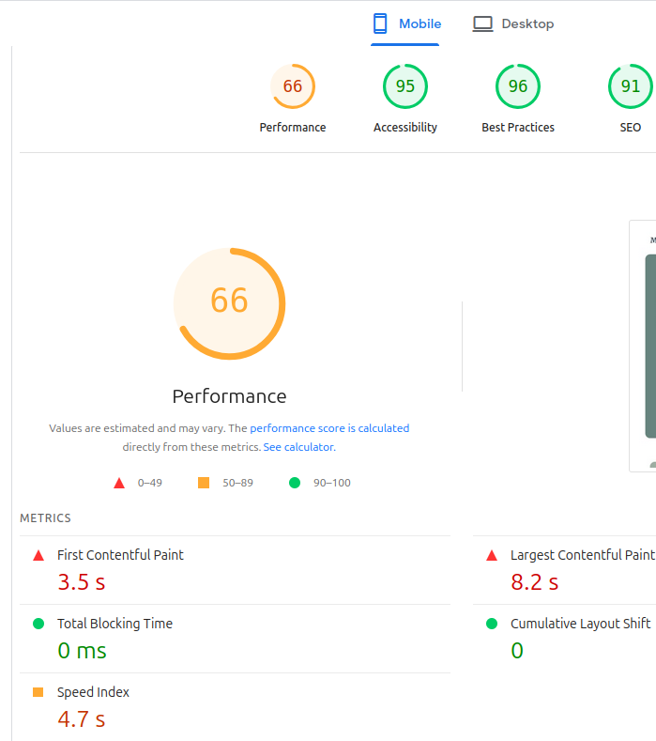  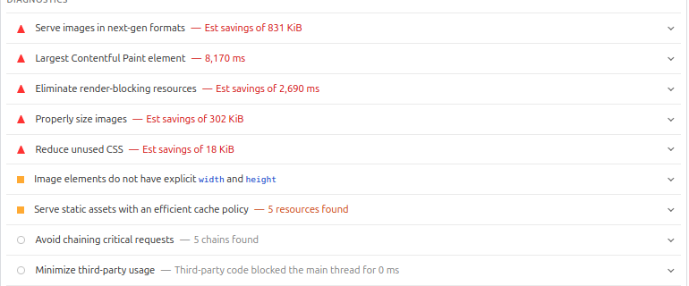 | 1. Serve images in next-gen formats  The images are too large, slowing loading speed. They need to be optimised.  2. Largest Contentful paint element – 8.2 s  The main visible content took over 8 seconds to load, which is too slow.  3. Eliminate render-blocking resources  I should defer or async CSS or Js files to avoid delaying page rendering  4. Properly size images  Some images are larger than displayed and should be resized to match actual dimensions  5. Reduce unused CSS  Some CSS rules are never used – eliminating them would save time when loading.  6. Some images do not have specific widths and heights, which can cause layout shifts.  7. Serve static assets with an efficient cache policy  I could set long cache expiration headers to avoid re-downloading elements on repeat visits

The main issues are thus the size of the images I use and redundant CSS. Once I addressed these issues, I got the following values:

…

1. Use one method for testing how fast your website is:
1. State how fast your website is.
2. Implement and document one change to improve the speed.
3. State how fast your altered website is.

https://pagespeed.web.dev/analysis/https-michaelmarkey-github-io-website_TU259-index-html/es16fav3lg?form_factor=desktop

Responsiveness

I used VS code while creating the website. It has a ‘Go Live’ feature which renders the website in the internet browser, allowing me to use Inspect on Firefox to view how the code relates to what appears on screen. The console option here has a ‘Responsive Design Mode’ tab that shows the website as it appears of different mobile, tablet and laptop/desktop screens. This is the main way in which I monitored the responsiveness of my site while developing it.

Once it was done, I hosted the site on GitHub, which then allowed me to view how it actually appears on my mobile telephone. I shared it with a few other people as well to get their feedback. This allowed me to see that my V1 contained too much content for a narrow screen, leading the user to feel like they were constantly scrolling through writing. I have a tendency to be quite verbose, so hearing that I had written too much was not a surprise.

I also used a website called ‘Responsinator’ (responsinator.com) to see how the webpage looked on different devices directly on my desktop screen. This website fits the content onto the screen of different devices, showing how it actually looks:

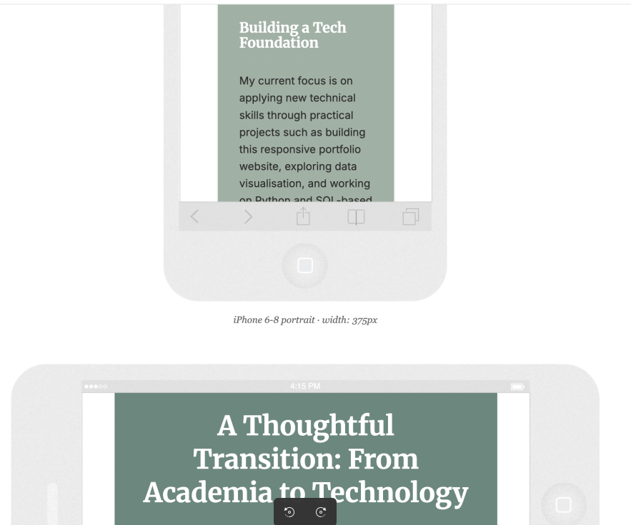 | 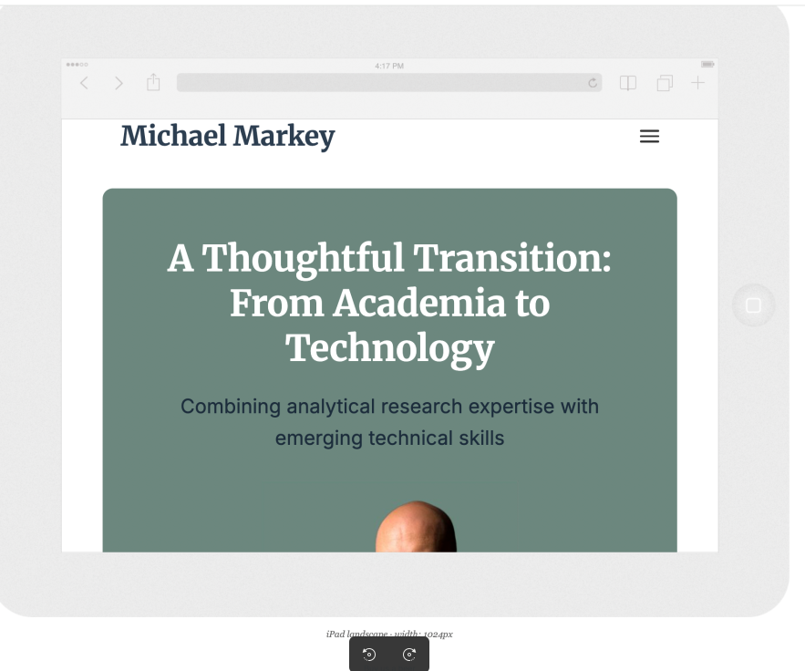

This site was very useful in deciding how I wanted to organise the view for tablets. I was not sure whether to keep a row (two-column) structure (like for laptops/desktops) or go with a one-column layout. Upon seeing the one-column layout on the tablet screen, I decided that it suited my approach – the headline comes first, then my image, guiding the user and creating a coherent path through the content. A two-column format led to the image and headline competing for attention.

I will come back to the question of the length of the content on mobile screens in the next section.
Evaluation

To evaluate the website, I decided to do an interview with a recruiter. I have known Xavier Guilbert, head of CXG (www.cxg.fr) for many years. His company specialises in head-hunting executives and often recruits IT consultants. He knows my personality and my move to IT. I felt he was in a very good position to give me personalised feedback. We spoke on May 10 for around one hour.
I could have carried out a survey to get a greater number of opinions on my work but I felt that this would be an unfocused way of evaluating my site as most of the people I know are not in my sector and would not know about hiring IT personnel. I also felt that the time between finishing V1 of the website and the deadline for this report was too narrow to get good representative feedback.

The advantage of doing an interview was that I got to spend almost two hours with Xavier. He had seen my website before and was able to give me his honest opinion and feedback from the start. Our conversation was in French but he works with English-language CVs on a regular basis, so I did not feel this was an issue.

He firstly confirmed that there was too much reading. He said that recruiters skim-read CVs so I needed to be more to the point. He also told me that my home page lacked a ‘hook’ to attract recruiters. Starting with a presentation of my move to IT does not speak to someone looking to hire, so I needed to re-evaluate how I created my first impression.

He directly told me to start with the job title that I want (or that I might want in the future) and to add the field directly under it. He then said to state exactly what I can do and why my expertise makes me the ideal person for the job. He guided me towards a new hero section on the homepage, along with a function, subheading, competence section and targeted background block:

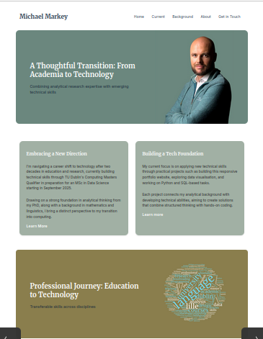  Home page V1 | 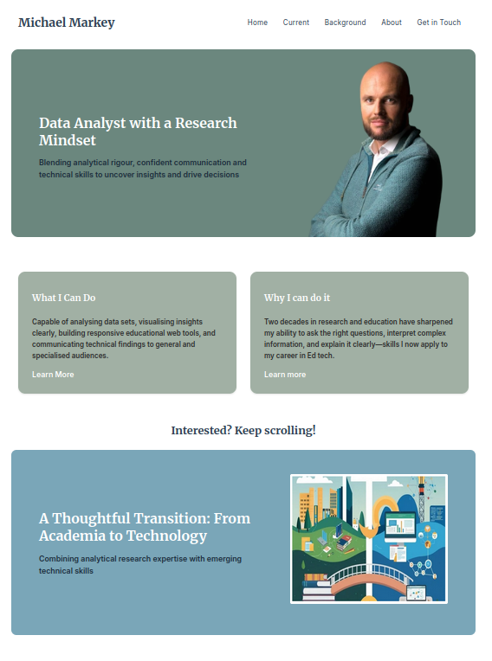  Home page after Evaluation

After the evaluation, I added a new hero section with a focused job title and list of related job-skills that I have to offer. I then shortened all of the information blocks on the website to make it more readable (and easier to navigate through on mobile devices), adding blocks below the hero section on the Home Page where I say what I can do and why I am the person to hire for my particular area.

Use of JavaScript and Technologies

In line with the evaluation brief, I included two distinct technologies to the website – iframes for videos and maps, along with a form where users could submit messages. I also used JavaScript on two separate occasions – one for the hamburger menu, the other (my own code) to allow for my Email address to be copied to the clip board with an alert to notify it had been done successfully.

Outcome

As shown above, now that I have fixed the issues with image sizes, my website runs much better on mobile devices. I also feel that using a mobile-first approach has allowed me to create a site that provides an enjoyable experience for the user on different devices. Finally, the Evaluation allowed me to improve the precision of my content and make myself more appealing to recruiters.

With regard to how the website fares mobility-wise, it would be fair to say that there is room for improvement. During the Evaluation, it was pointed out to me that some users have issues clearly distinguishing colours and that distinguishing content through colour is a design problem.

I have not carried out a keyboard navigation test, meaning that I do not know if my site can be navigated only through using the keyboard. The main method of navigation is through menus, with no way of skipping to the main content and by-passing menus for individuals who find them hard to navigate. I could also have made borders more visible.

In terms of future development, I would need to address the mobility issues outlined above. I would need to make my Git Repos more accessible – at the moment, they merely ‘store’ my work but there is no clear ‘Read me’ file and the content is not logically arranged. There is also plenty of scope to add more interactive features and make the site less ‘word-centric’ and content focused.

For future development, the HTML and CSS would also need to be more ordered and better arranged. I set out to bring my own vision to life but I do not have the time to neatly order my work so that I can reuse the code to expand. This is due to a lack of time and planning, so future expansions would firstly require better labelling and organisation.

In conclusion, I feel that the website is a good first attempt at such a project and provides a solid foundation to continue building into the future.

3. What are the recommendations if the web site was going to be developed further?

Use of Javascript
Use of other technologies

Speed

1. Use one method for testing how fast your website is:
1. State how fast your website is.
2. Implement and document one change to improve the speed.
3. State how fast your altered website is.

May 11 - https://pagespeed.web.dev/analysis/https-michaelmarkey-github-io-website_TU259-index-html/es16fav3lg?form_factor=desktop

Responsiveness
Use one method for testing how responsive your website is.

Evaluation

Use one evaluation method to assess the usability and functionality of your website.
1. Description of evaluation methods e.g., survey, interview, expert review … and
why they are appropriate

Interview – HR – knows my background, tailor advice to me
Extra section, shorter explanations (better for mobile view), guide the recruiter more
Extra issue – accessibility (Daltonien)

Outcome

1. How did your web site fare?
2. How was it mobility-wise?
3. What are the recommendations if the web site was going to be developed further?

